

Technical Report and User Guide.

Formulated by:

TeamDeManMet

**Abstract**

The purpose of this project was the create a viable product that implemented image recognition technology in order to retrieve data from images in conjunction with TourDeManc aims.

In response to this the team created a website that used the Google vision API to retrieve numbers from cyclists bibs using PHP and XAMPP.

The main issue with this was finding an image recognition technology suitable for the project and once we found it, implementing this into our product.

The product has limitations due to the technology available to the team. In the future as this improves and the recognition gets better, the products functionality of retrieving data should improve.

# Contents

**1.0 Report** **3**

1. 1 Background of the project 3

1.2 Requirements of this project 4

1.3 Technology Uses 5

1.4 Development Implications 6

1.5 Design of the product: 6

1.6 Outline Of The Product: 13

**2.0 User Guide:** **14**

2.1 Website Setup and Navigation 14

2.2 User Specific Actions 15

2.2.1 Administration Accounts 15

2.2.2 Photographers Account 16

2.2.3 Event Organisers Account 16

2.3 Usability Features 18

**3.0 User Testing:** **19**

**4.0 Handover Report:** **24**

4.1 Enabling the API 24

4.2 Running the PHP Files 33

4.3 Future Updates 35

4.4 Passwords and accounts 35

**5.0 Developer Contacts** **37**

# 1.0 Report

## 1. 1 Background of the project

TeamDeManMet is a project inspired by the charitable racing events company TourDeManc. We are comprised of university students, Victoria Hanley(Project Manager), Joseph Harwood(Technology Lead), Jacob Edwards(User Advocate) and Alex Berridge(Client Advocate) and aim to help the company by building them web technologies that will help them build on their success.

## 1.2 Requirements of this project

This main requirement of the project required the team to produce a website where pictures can be uploaded and stored for each event.

This should contain in order to deliver a minimum viable product :

* Image recognition technology that once a photographer user has uploaded it will pull the rider number out of the picture and assign it to a specific rider.
* Allow administrators to add rider lists and assign them to events
* Allow event managers to create by events
* Allow administrators to analyse and delete any photos in the case of misuse.
* Allow riders to search the gallery with their rider numbers in order to view pictures they are in.

The full requirements of the product can be seen below in figure one.

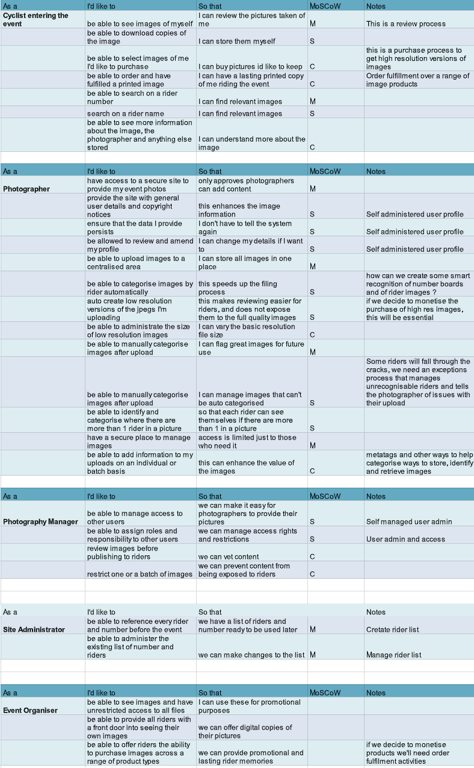

Figure one: Requirements of the project

## 1.3 Technology Uses

The website was developed to compliment the original website built by TourDeManc. The unique selling point of the website is that it offers a bespoke product with image recognition technology that will recognise riders by their rider number, so when the rider searches their number in the gallery they can view their photographs.

## 1.4 Development Implications

This technology, as provided by Google Vision, has been developed to identify faces, places, numbers and colours in images. Implementing this technology in this way means that photographers do not have to go through the lengthy task of assigning the riders photographs individually or the riders having to sort through the images to find their own pictures. By using this technology, the product is not just on the forefront of visual recognition but executing in a way that will help the charity as it grows.

## 1.5 Design of the product:

The product the team designed was a visually pleasing website built on the programming language PHP. During design, the product took inspiration from the Tour De Mancs main website in order to present fluidity between this and the product, the team also investigated similar websites held by competitors.

The website presents several different webpages but they all share the same format consisting of a black, red and white. As well as the them all pages also consist of :

* A navigation bar is black with a white font for the links, for added usability purposes, the navigation page on the navigation bar will turn red showing the user which page they are on.
* A logo of ‘Tour De Manc’ on the left hand side, the logo is a way of visually combining the websites whilst also acting as a link to the original website.

The homepage as seen in figure two, will present as a welcome page the website. This will briefly outline the website, how to use it and have images from the TourDeMancs races to be visually pleasing and entice people into the website.

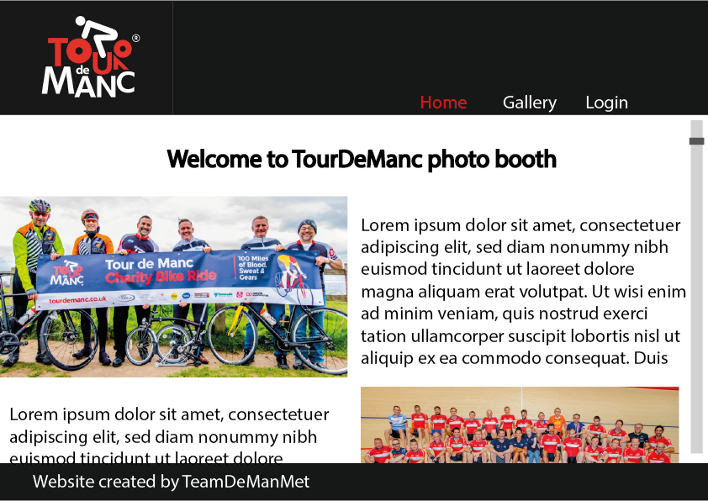

Figure two: homepage of the website.

The login page as seen in figure three, will present a simple form consisting of an email and password text box for the user to enter their credentials. During the process we chose to remove the sign up form and made creating accounts into an administrator tool instead, this was due to removing rider accounts and avoiding misuse of account creation by people who haven’t taken part in the race.

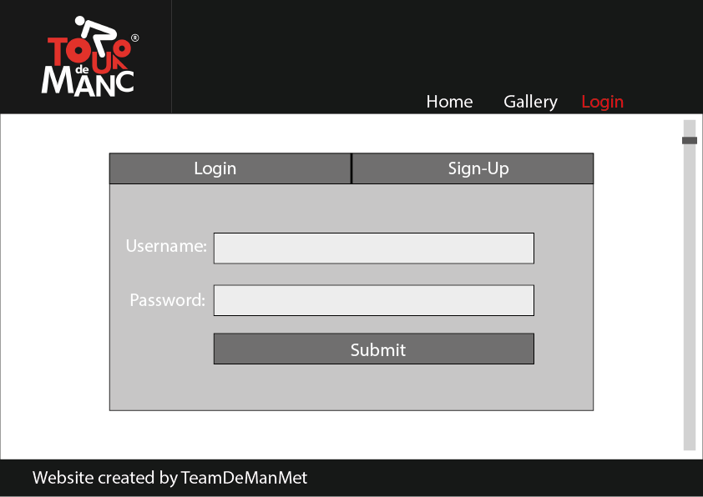

Figure three: Login page.

The gallery (Figure four) is a public area for any user to view, regardless of login credentials. Users are able to open the images to view in a higher quality, download the image, and ‘tag’ themselves in the image so it is easier to search for a particular image.

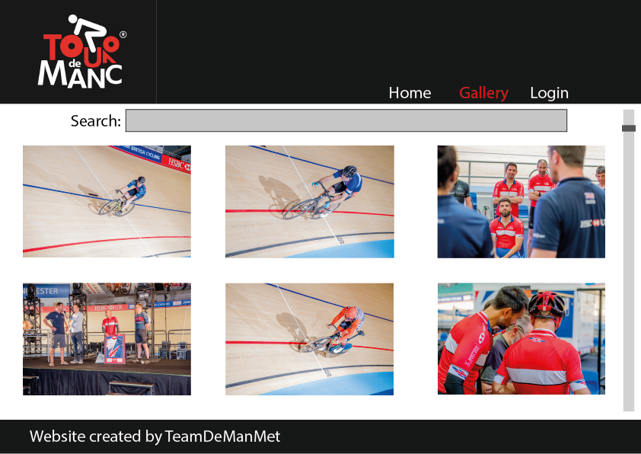

Figure four: Gallery page.

The profile page (Figure five) displays to a logged-in user their relevant details, an option to update the details and an option to change their password. Photographers are able to upload images to the website, event-organisers are able to establish a new event and assign riders to said event; admins can create other users for the website.

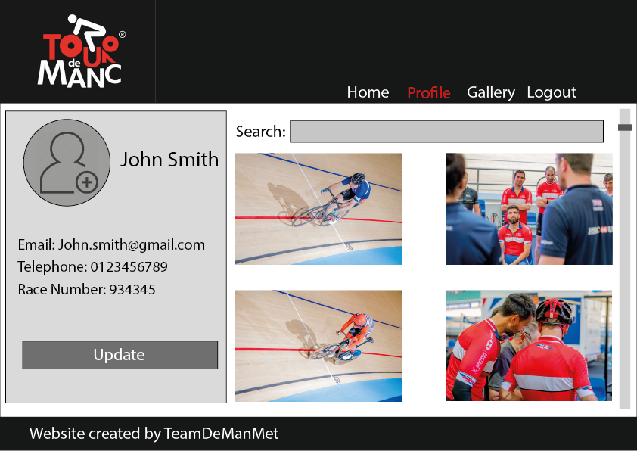

Figure five: Profile page,

The backend of the product was constructed based on the entity relationship diagram as shown below. This was created using visual paradigm. The database, entities and attributes will be created in PHP, which can be viewed phpmyadmin. An attribute refers to a member of a table which, with the other attributes, forms a record of data.

In the user entity, the required attributes are username and password as they will uniquely identify a user (created by an admin), who can then update their details through the website.

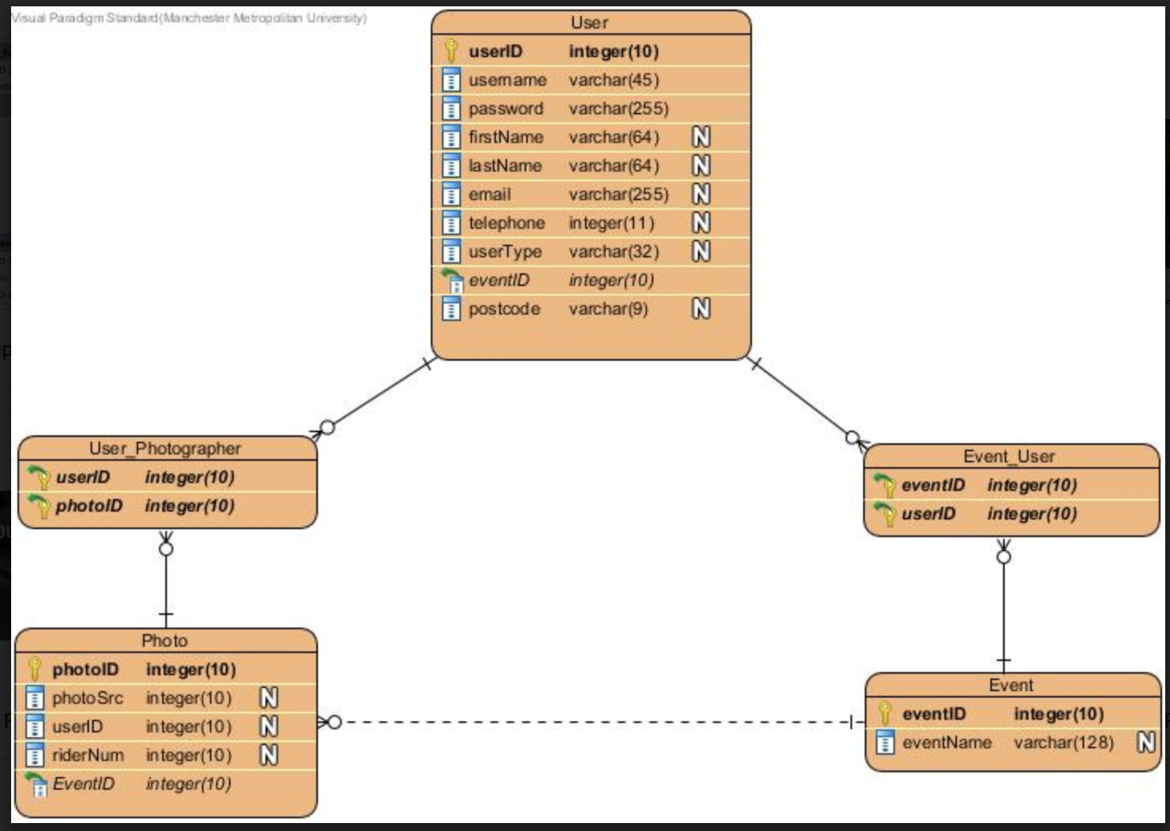

Figure six: ERD of the database design.

## 1.6 Outline Of The Product:

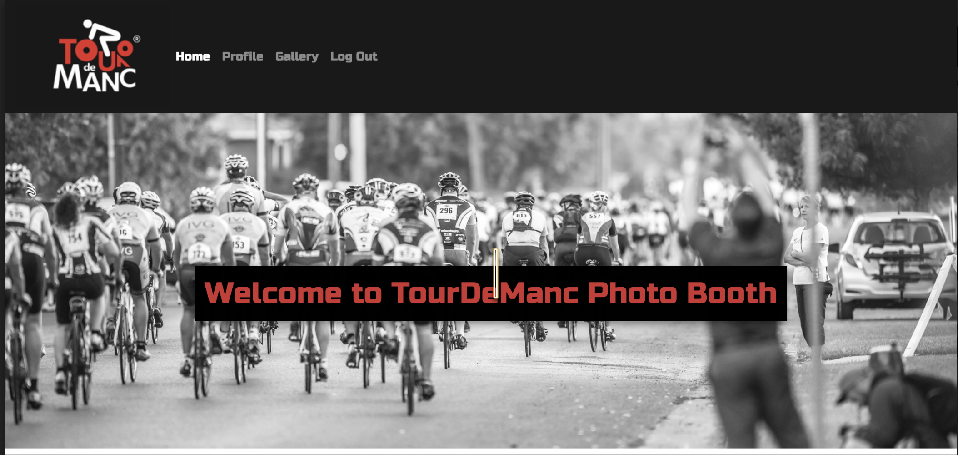

Figure seven: Finished version of the website

Figure seven shows the final version of the finished website.

* The front end of the finished website is similar to that of the website in the design stage, following the same format and colour scheme.
* The website boasts a powerful API from Google Vision. This means that when a photographer uploads an image, it will be ran through the API to the back end of the website, which will then extract the cyclists’ numbers produced by the API, to be stored in the gallery so that users can search for their cyclist number and find corresponding images.
* The team were aware however sometimes the API may not be appropriate and will not be able to retrieve numbers, this was particularly the case once the races were finished and people were relaxing and not wearing race numbers. Due to this a button was created so they could assign themselves to a photo if they saw themselves in it, this means in future searches for their cyclist number would be retrieve this image in a search.

# 2.0 User Guide:

## 2.1 Website Setup and Navigation

* Run the create data php script to populate the database with user information, photo data and event information. Once you have done this you will only need to do this once on the machine, however if the user desires to run this on another machine you will need to reload this page again as the data is stored locally.
* Open the index.php page, this will give the user a basic idea of TourDeManc and information on each users page.
* In order to conduct a search for their photograph, the rider should navigate to the gallery page using the navigation bar, then use the search bar to enter their number and select the event in which they wish to search for using the drop down box.
* If you have an account you can log in using the username and password provided by the admin.
* Once you have logged in you will be directed to the profile page.
* If you wish to log out please just select the appropriate button on the navigation bar.

## 2.2 User Specific Actions

As previously mentioned, the users actions will depend on what type of account they are logged into.

## 2.2.1 Administration Accounts

The most powerful account on the system, should only be used by someone with administrative rights.

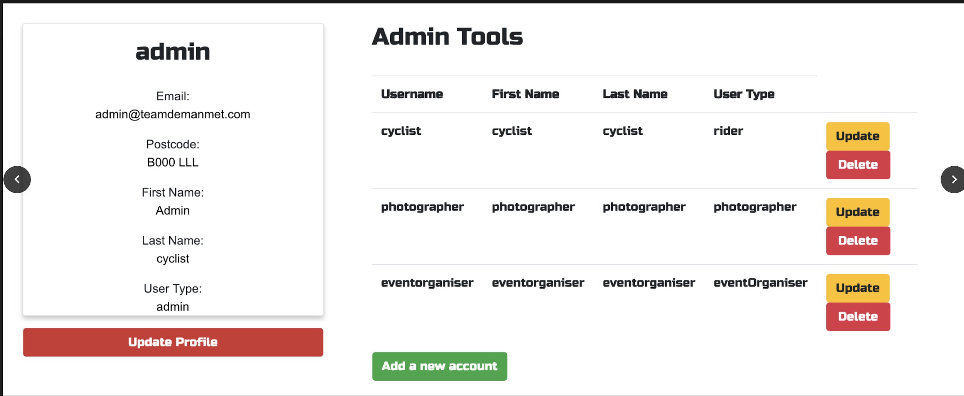

Figure eight: Administrators account.

* The administrator can add user accounts for photographers and event-organisers.
* Edit or delete user accounts; the admin can view all user accounts and can edit or delete these at any time from the profile page.
* View and delete all images on the website. Although most users of the website do not require a login, only the administrator has the ability to delete any photos that they deem to be ‘inappropriate’.

## 2.2.2 Photographers Account

Photographers accounts should be reserved for professional photographers who cover the TourDeMancs events.

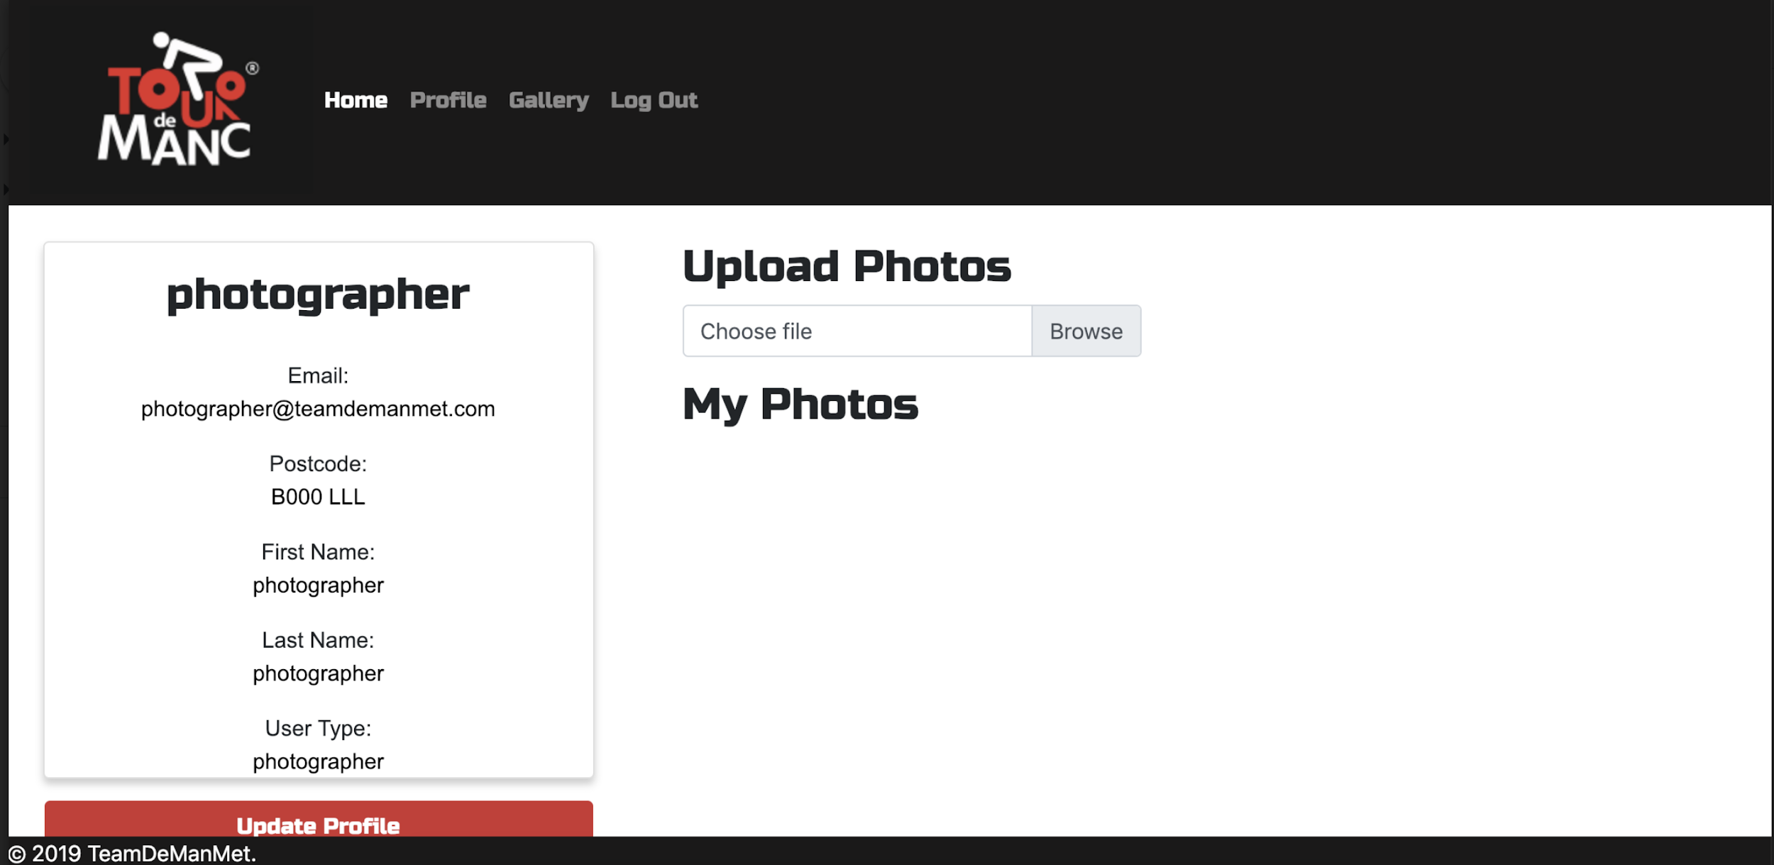

Figure nine: Photographers account.

* Photographers main functionality is the ability to upload pictures to the website.

## 2.2.3 Event Organisers Account

Event organisers accounts should be reserved to professional events-managers who organise TourDeMancs’ events.

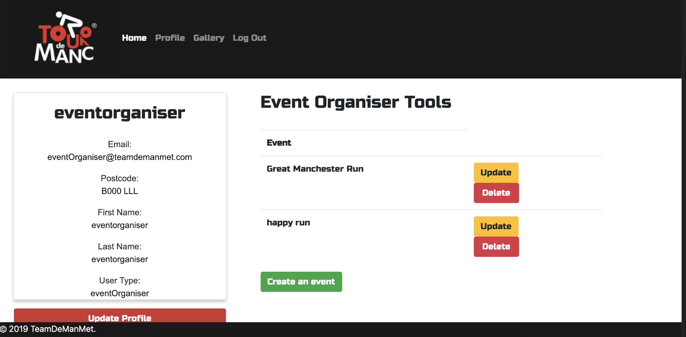

Figure ten: Event organisers account.

* Event organisers can create new events to which the photographers can attach photos
* Events these can be updated and deleted by event-organisers.

## 2.3 Usability Features

The website can be moderated for different users who may struggle with the standard website.

* For users who may struggle with poor sight, the website has been modified to accommodate screen readers. By using screen-reader-friendly formatting, the pictures, titles and logos can be identified by a screen reader.
* The website users few and distinct colouring (only black, white and red), making it easier for colour blind/deficient persons to still operate the website.

# 3.0 User Testing:

After the project had been finalised, the team completed user testing from a sample size of 15 people, although it can be noted not all respondents responded to all questions.

The test was completely by giving users the software and asking the to test the website. Once they had used the website they were asked to fill in a feedback form on Google forms.

The vast majority of feedback was positive and we had a wide range of answers.

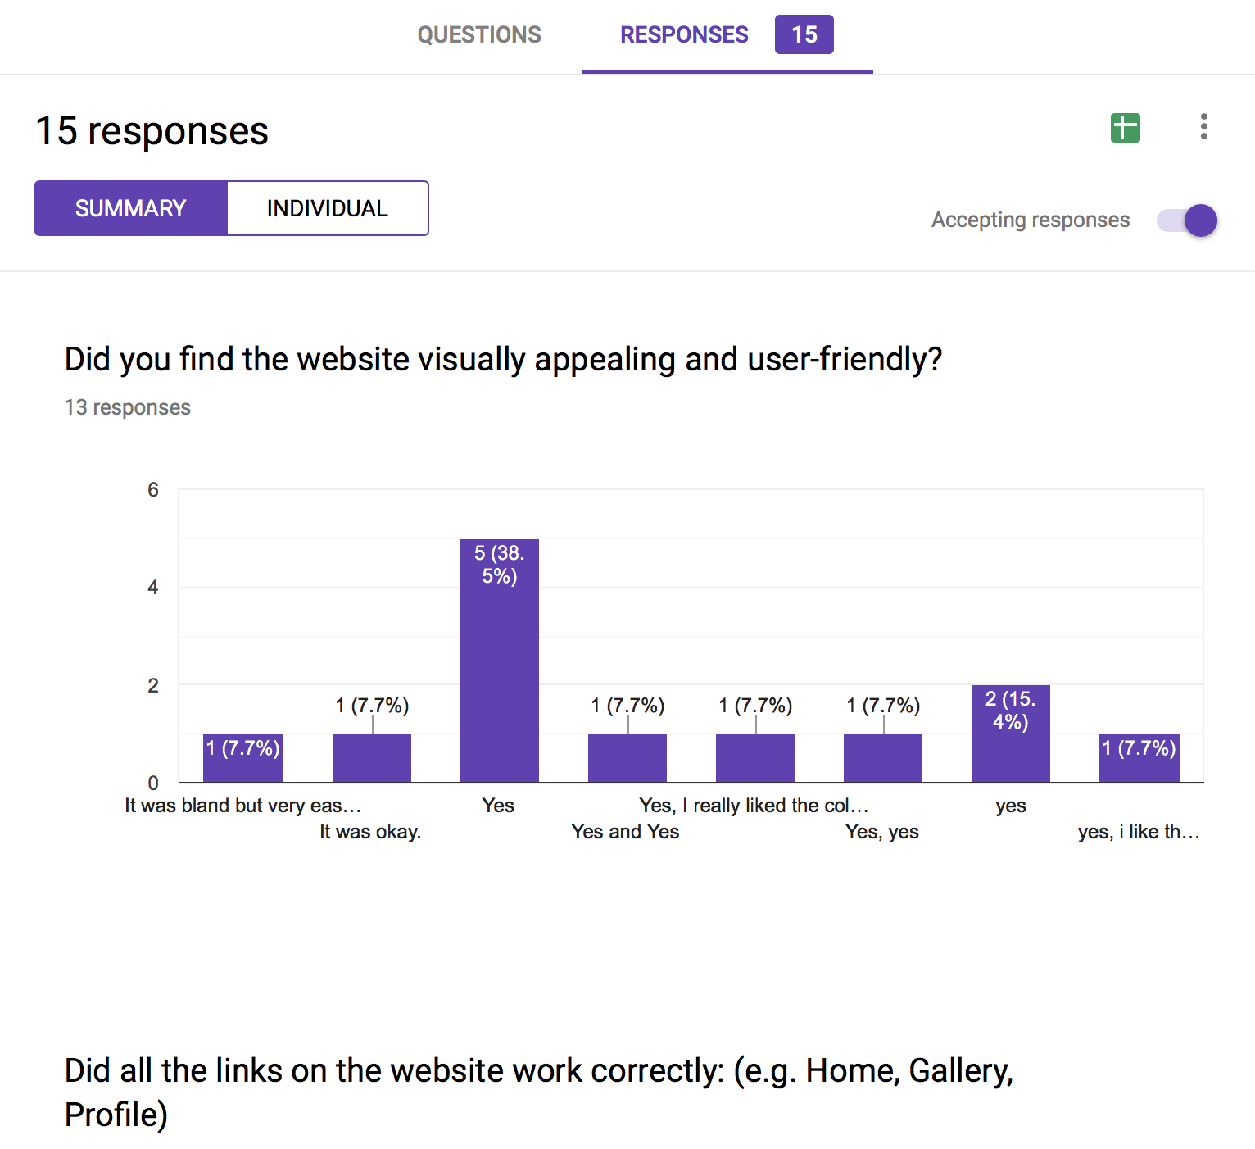

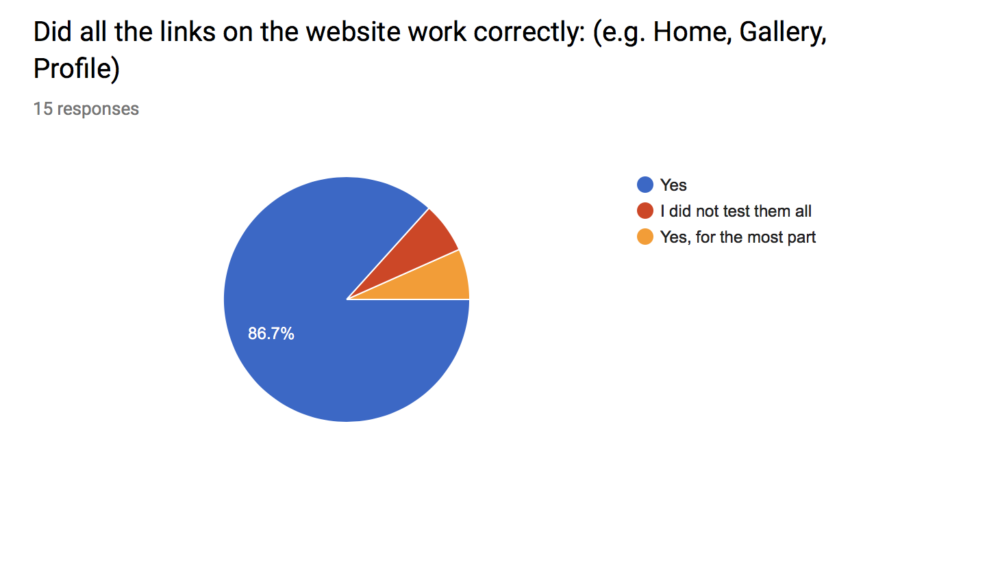

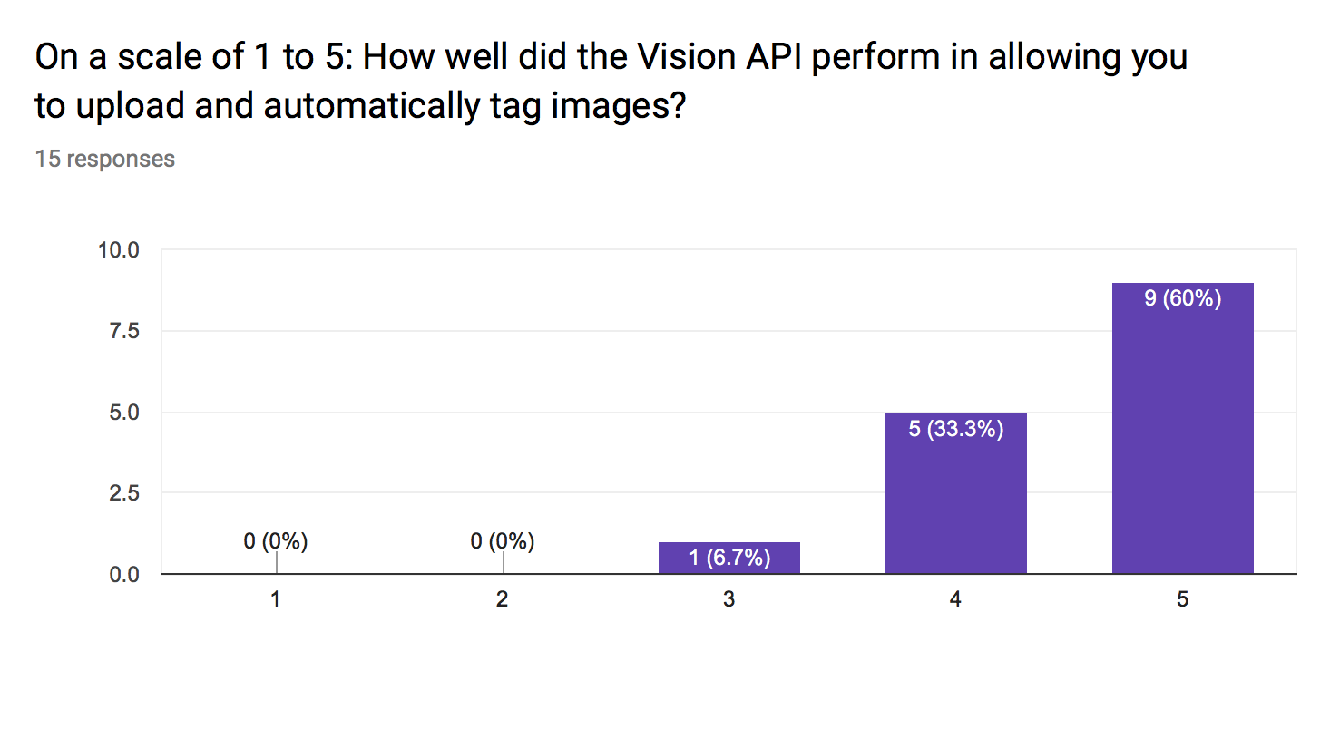

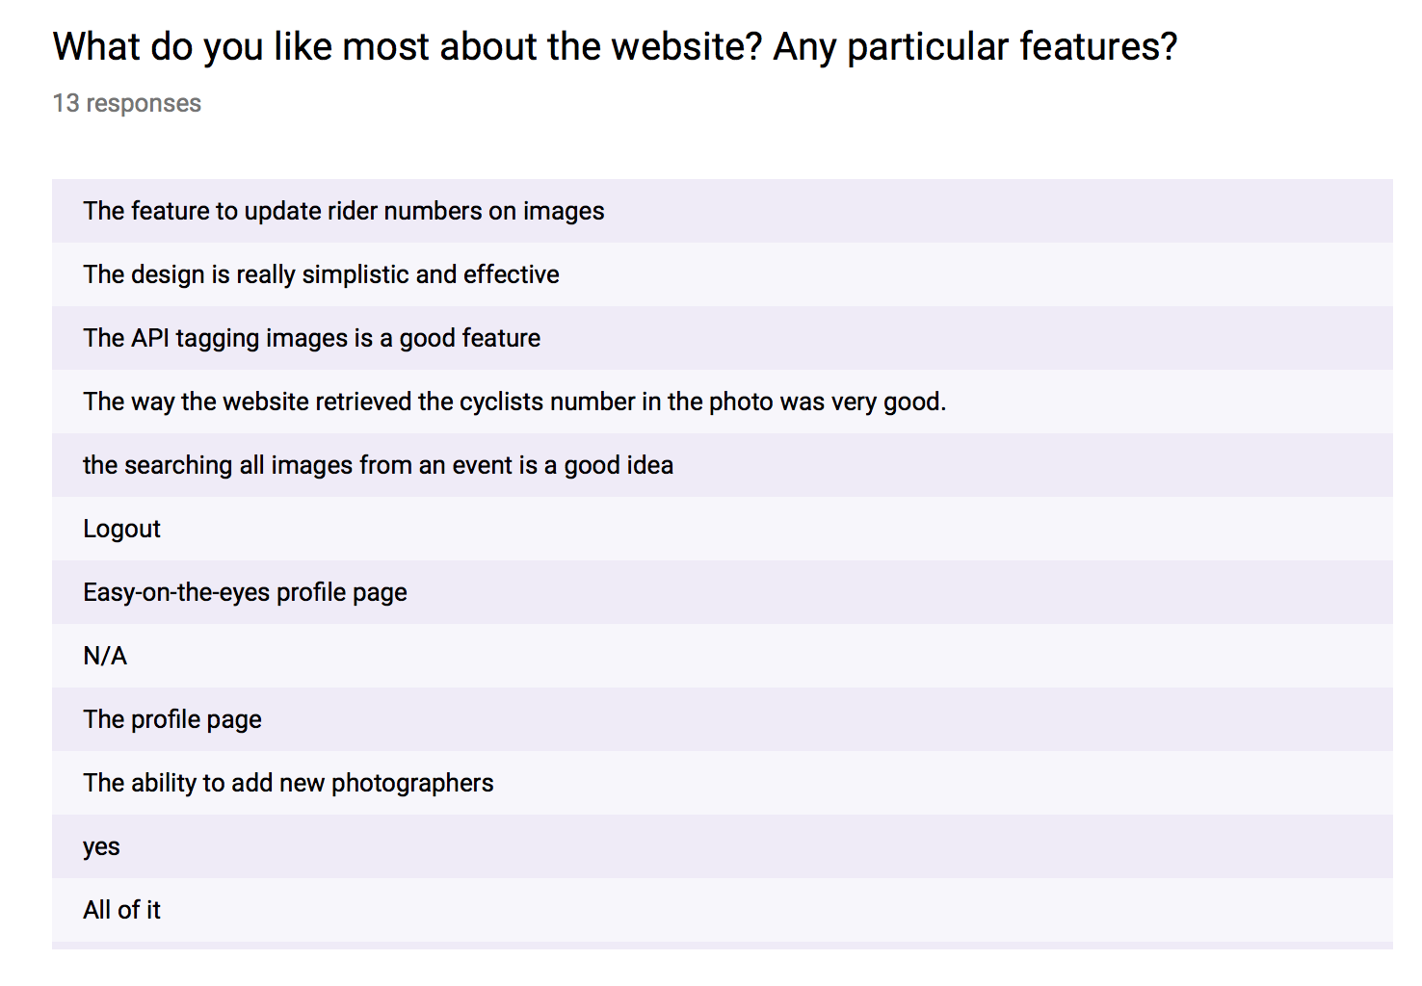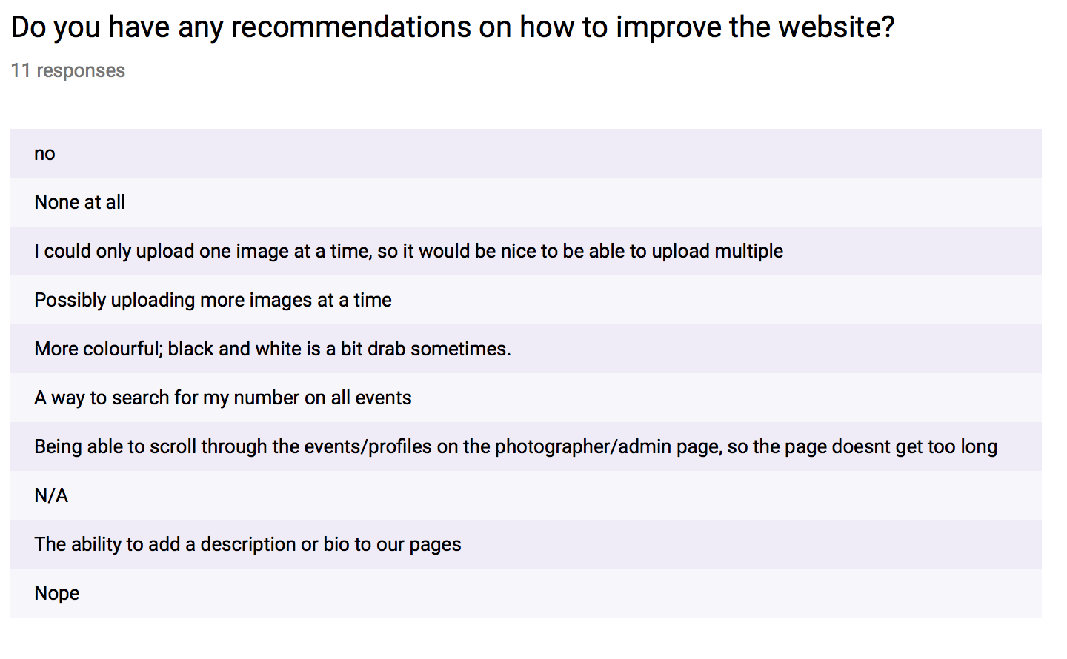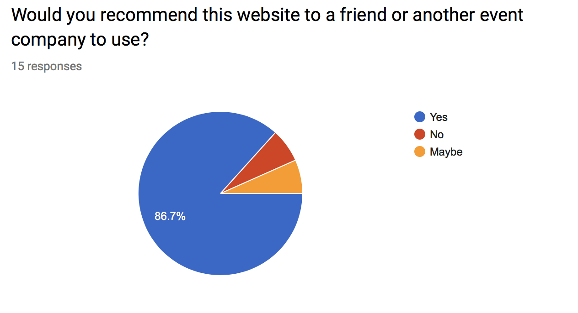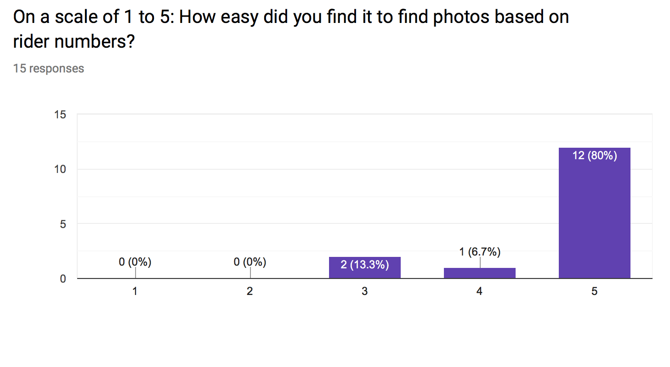

From the feedback, the team concluded the design was strong and most people found the website visually pleasing and the API seemed to work well in the testing.

The most common recommendation was a feature to batch upload, this was something that team had considered on the initial design but when it came to implementing this feature with the API it was very difficult and as this wasn’t a feature on the user requirements the team decided this was not a priority.

The other problem we encountered was someone stating the links ‘worked for the most part’, as the feedback was anonymous we couldn’t follow this up but we re-tested all of the links and found they were working so concluded this could have been a mistake or a bug on the users system.

One recommendation we found interesting was the ability to add a description or bio to the image, the tech lead initially decided to implement this but we were concerned over misuse as you do not need a login to access the gallery feature or people trying to write over each others bios and descriptions causing aggravation.

# 4.0 Handover Report:

The below will guide you through implementing the product onto your own system. The follows steps will detail each page of the system, how they interact with each other and how you will need to change them to suit your own requirements.

## 4.1 Enabling the API

The project runs on the API Google Vision, this provides a thousand free requests a month, so the user can run the analyse image search a thousand times a month. However, this requires billing details to sign up to the account. As one of the members of the team used an unused card to develop this, this account will not be passed on. This will mean the end user will need to generate their own API key and implement this into the project. This is fairly straightforward to do using the following steps.

Create a google vision profile either searching for this through Google or using the following link, https://cloud.google.com/vision/.

Once you are on this page, select ‘Try it for free’.

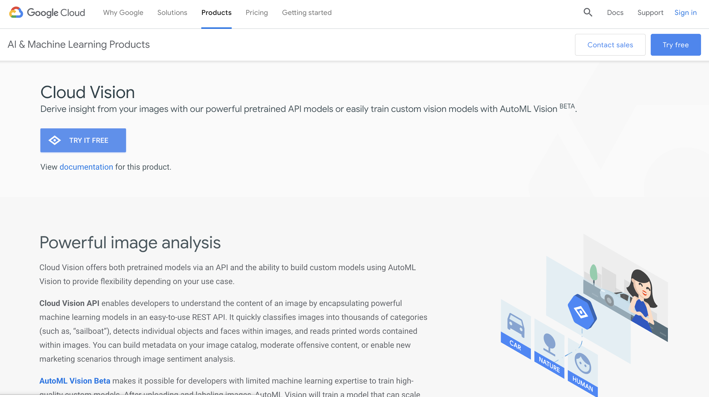

Next you will come to an account sign up page, follow the instructions on this and add your billing details.

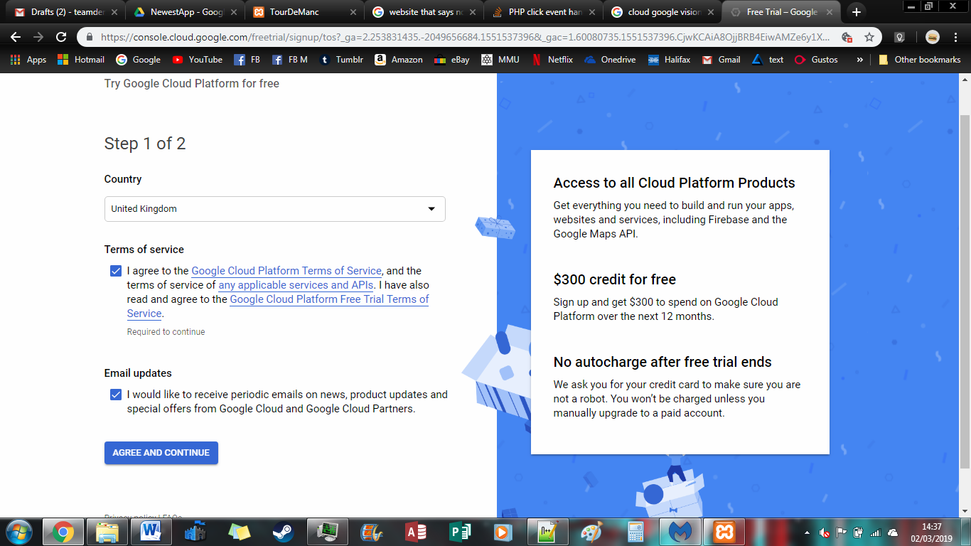

After this, you should come to your Google Vision console page. This will show you all of the statistics of your requests and any estimated billing costs.

In order to get the API key select the downwards arrow on the top of the dashboard where it says Google Cloud Platform.

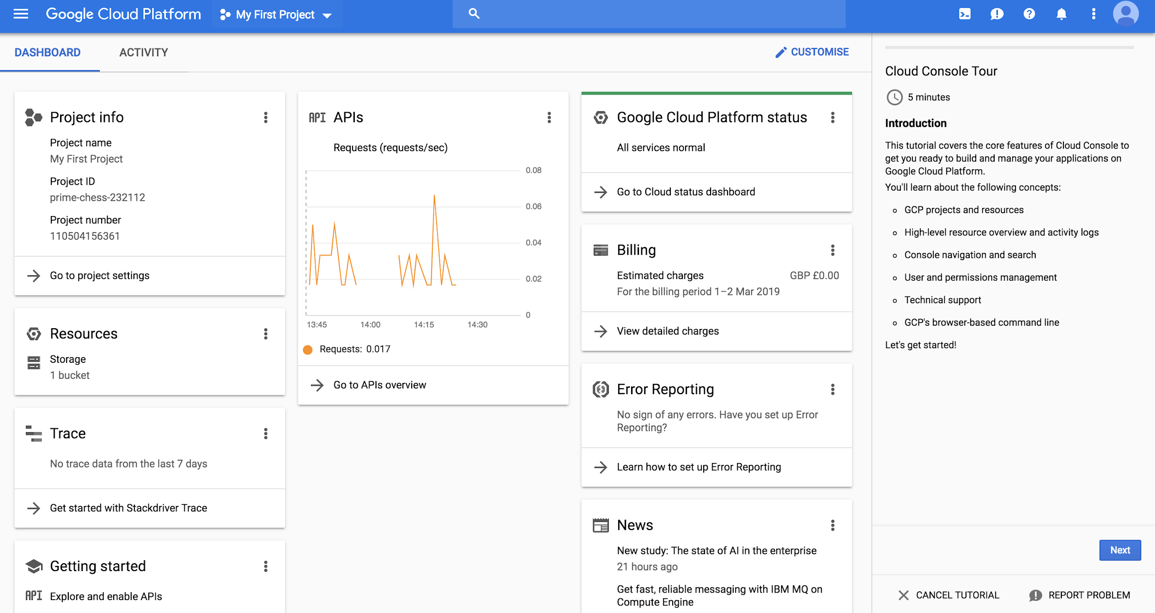

A pop up box will appear, please select create new project.

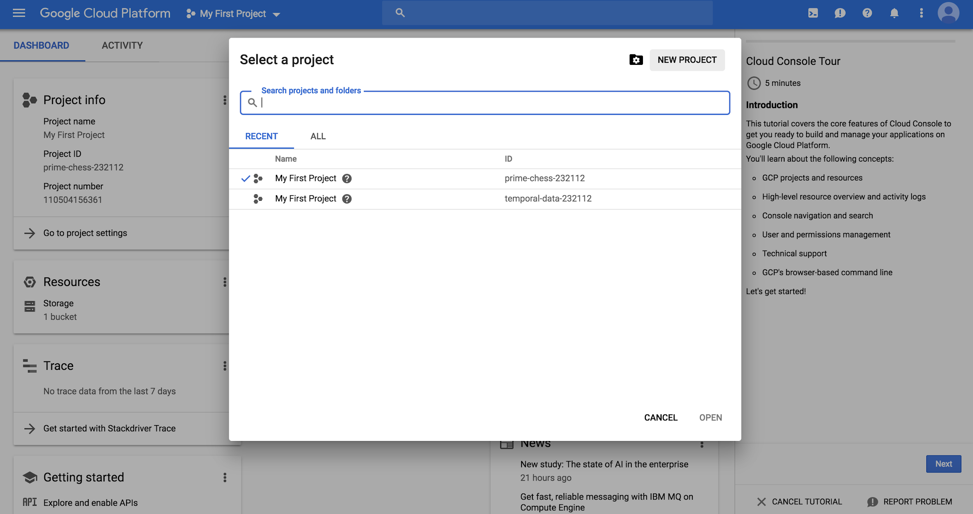

Enter the project name and press create.

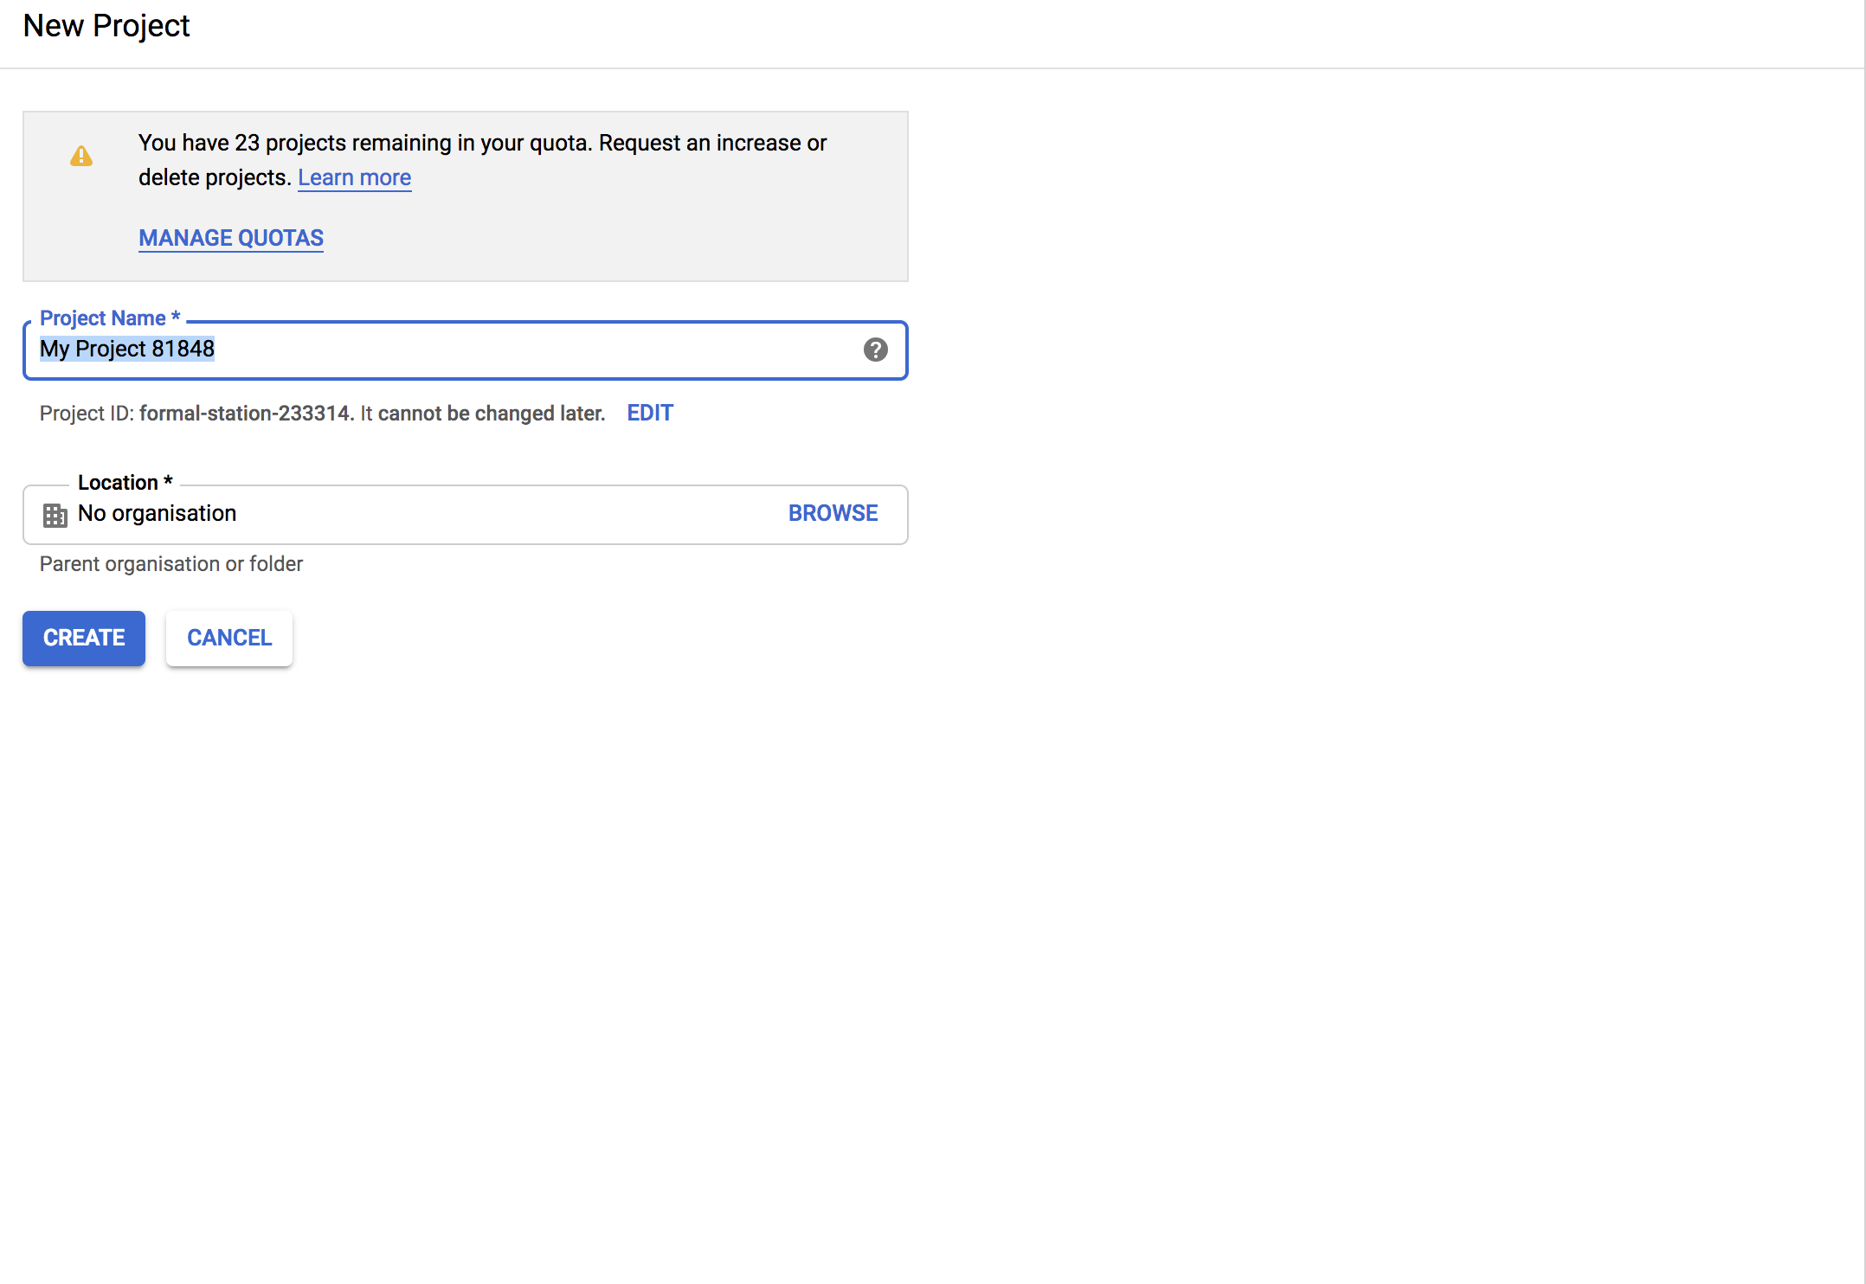

Select your projects dashboard and select ‘Go to APIs overview’

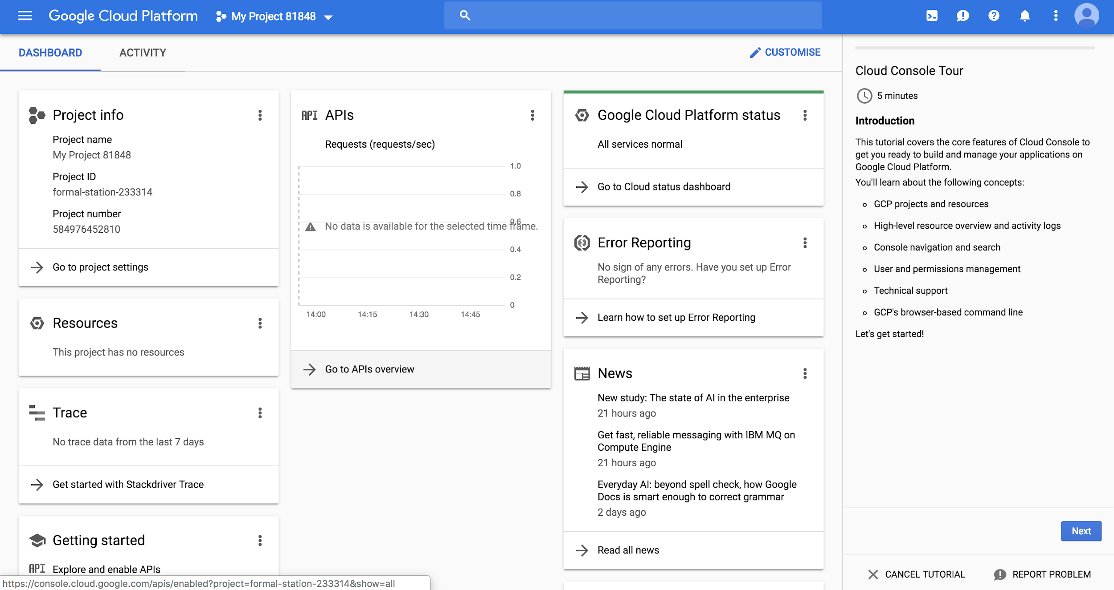

Select ‘+Enable APIs & Services’, this will then take you to the API Library. Once there you can conduct a search for ‘Google Vision’. When you see the below click on it, this will take you to an overview, simply select ‘Enable’.

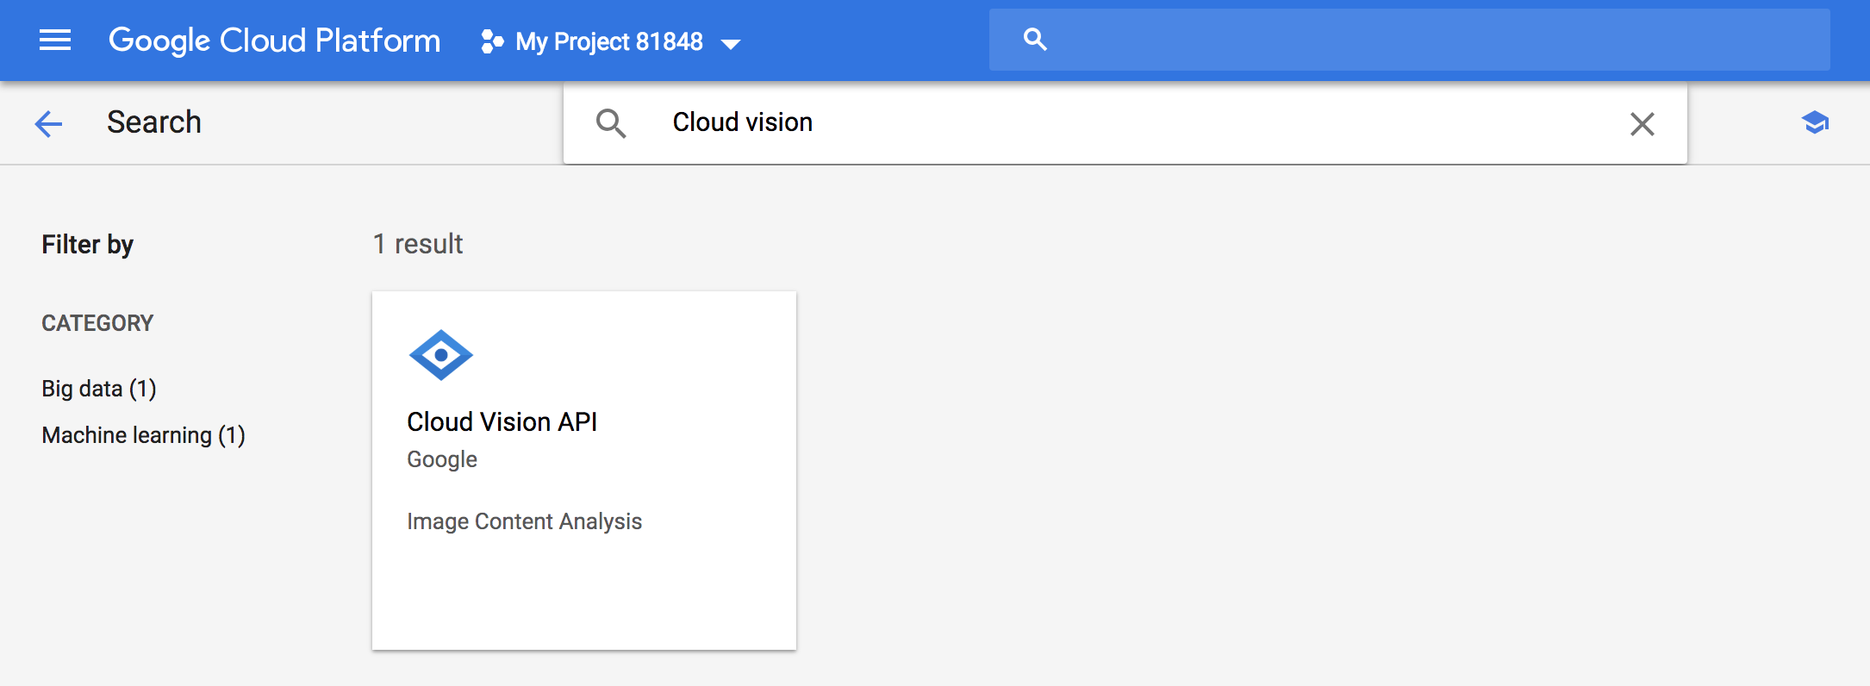

Once you have selected ‘enable’, you will be taken back to the dashboard. This may take a few minutes to load with a circle rotating on the page but this is normal. Once this has loaded you should see the below.

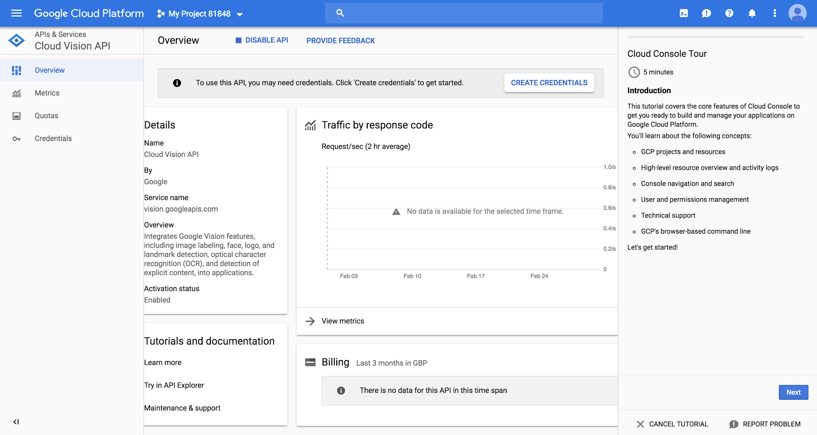

Select ‘create credentials’.

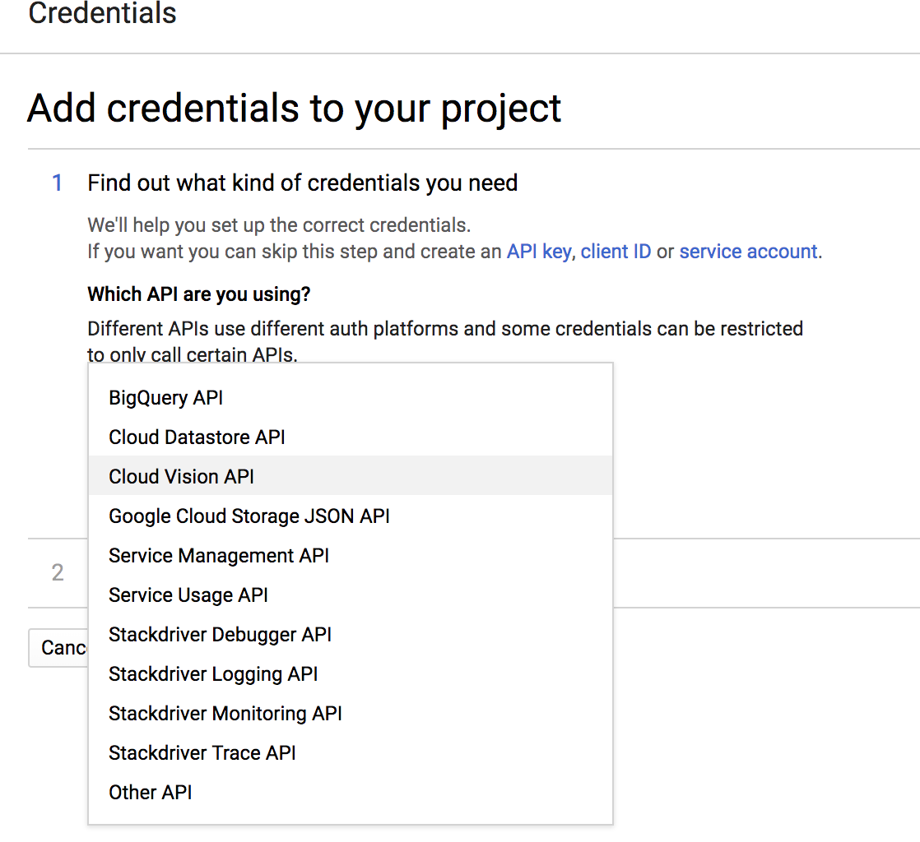

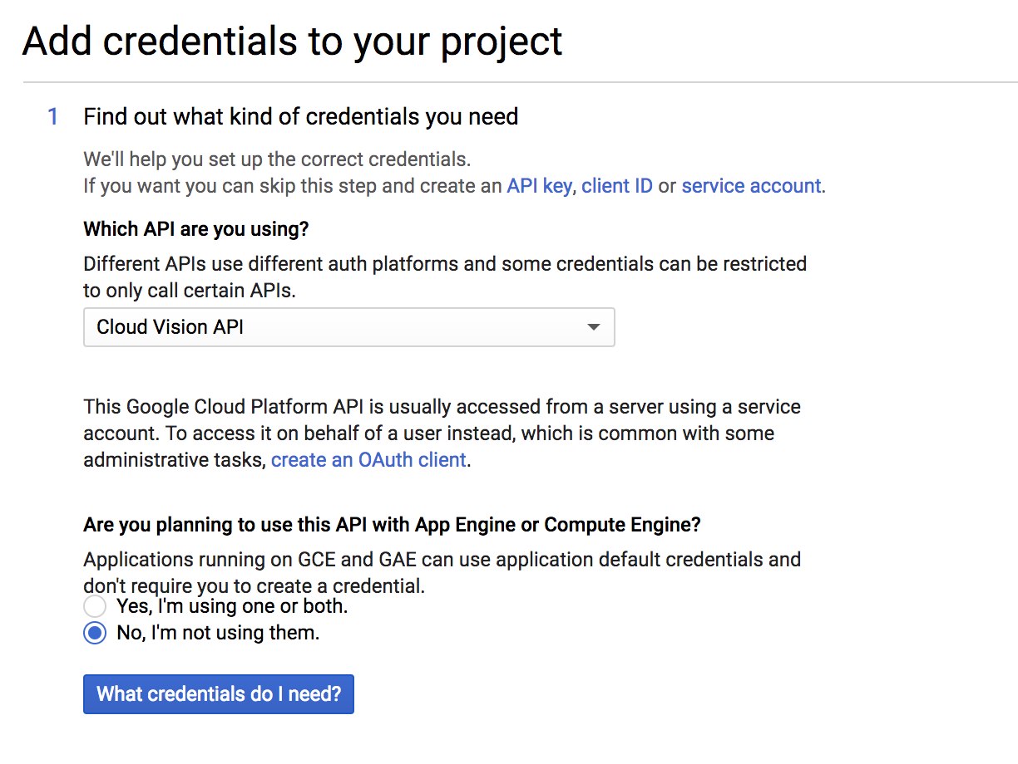

Select ‘Google Vision API’ and ‘No, I’m not using them’.

From here you will need to set up your service account, firstly select role>project>owner, this will give you access to all the resources. Then give the account a name, I have used ‘image recognition’ in the pictures below.

Leave the ‘JSON’ element selected. This means the data will be retrieved in a JSON format which our website will then read.

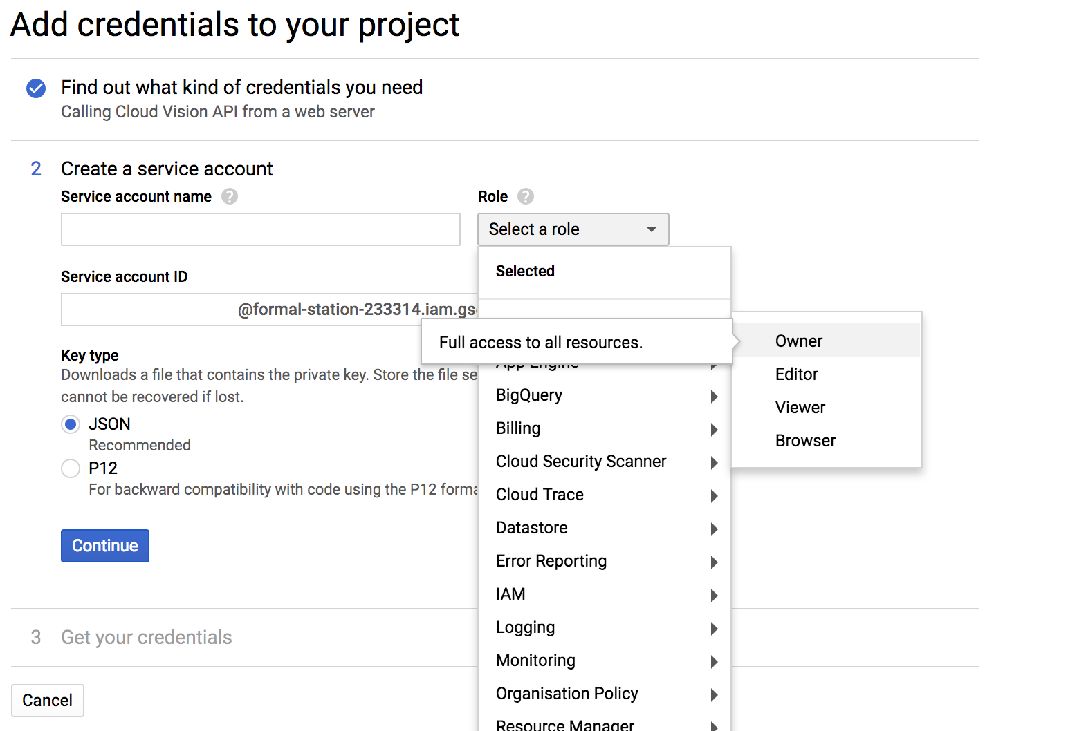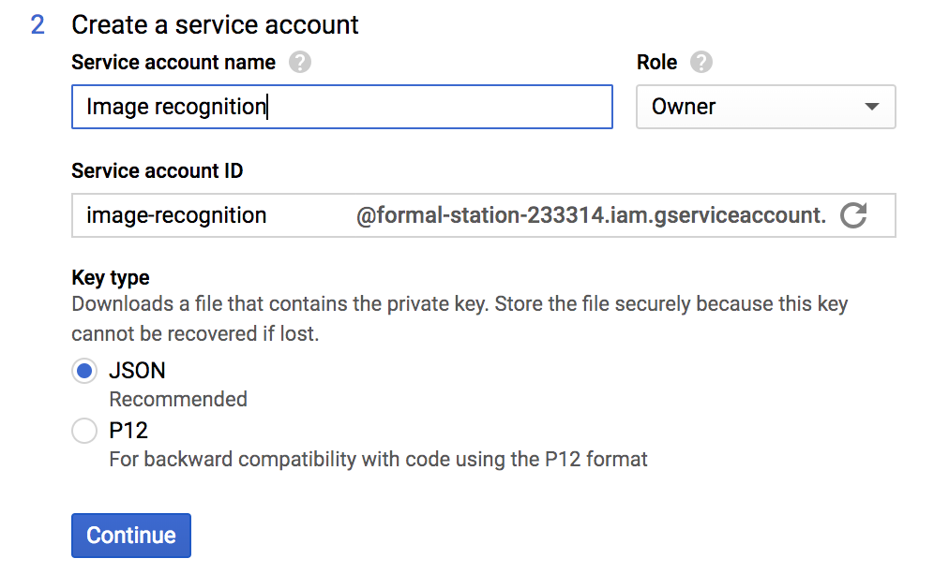

This will then download a json file to your computer, you can open this in whichever code editor you use, the example below is using Brackets.

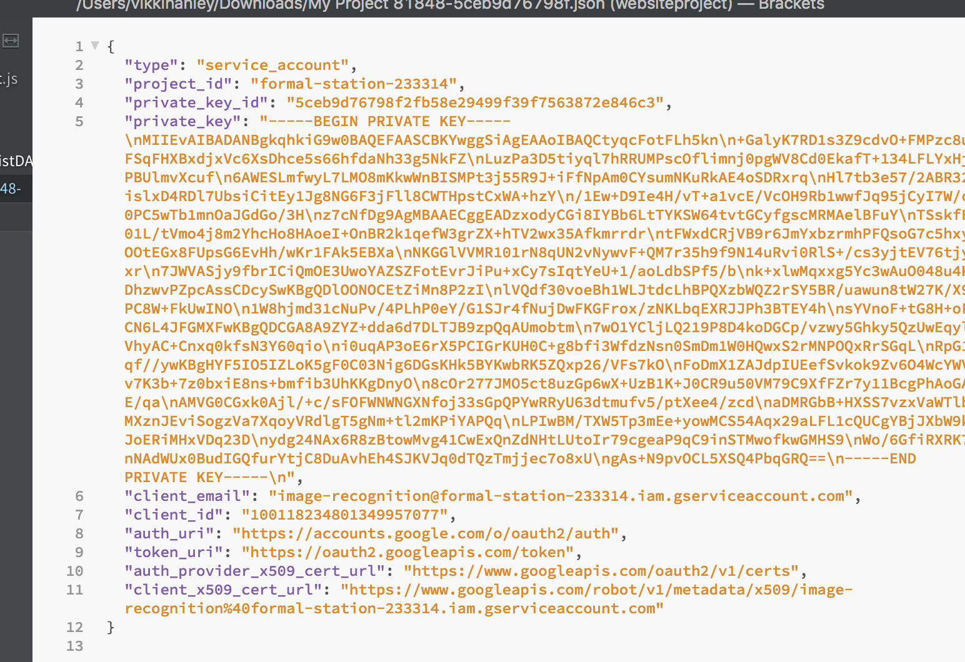

Copy and paste the whole key into the key.json file in the product, this should now enable you to use the system.

## 4.2 Running the PHP Files

**create_data.php:**

Creates database called tourdemanc, which can be viewed on [phpmyadmin](http://localhost/phpmyadmin/).   
Populates the database with tables required to interact with the website. These are event, photo, users, event_user, user_photographer.  
Populates the users table with the user types- admin, photographer, event organiser.  
Populates the event table with an event called ‘Great Manchester Run’.  
Populates the photo table with a photo stored in the ‘images’ folder.  
For security purposes, the users passwords have been hashed with sha512 and salted with the salts stored in connection.php.

**header.php & footer.php:**

These scripts will run concurrently with each of the web pages displayed on the website. ‘Header’ displays the navigation bar and search entry box at the top of the page, using bootstrap to control the layout of the page. Header also requires ‘connection.php’ and ‘validate.php’, so that the scripts methods and variables can be read by the other scripts that all ‘include’ header.php.

‘Footer’ prints the copyright footer to the bottom of the page.

**connection.php:**

Stores six strings related to each page of the website. The front and back salting for password security, along with all the strings for database access. This minimises the repetition of scripts being written.

**validate.php:**

Holds the functions that validate strings and integers. ‘validate_string()’ takes three parameters, the string, it’s minimum value and maximum, and is the most commonly used function through the programs scripts. The sanitise() function will escape all dangerous characters from any entered strings before they are stored in the database to avoid SQL injection attacks.

**login.php:**

Prompts the user to enter a valid username and related password. Once the user submits the username and password, they will be run through the login script. The login script will take the password and username from the http POST array, sanitise and validate them, and then compare them with the data in the database; if there is a match then a prompt to the website will be shown to the user, however if it fails then then the login form will remain.

**profile.php:**

The profile script first checks that the user is logged in, then retrieves all the user information stored in the database using the username from the http post request as a search parameter it will then check the users usertype it has retrieved from the database and then render different page functionality and view based on their user type.

**update_user.php:**

The page firstly check that the user is logged in, if this confirms whether the user is logged in the page retrieves the users details that they have the permissions to change. Once the user submits the form these are sent to the post and validated and sanitised before they are updated in the database. If the page does not confirm the user is logged in, it will show the user a page stating they are not logged in and guide them to the login page.

**index.php:**

This functions as the home page to the website. It uses the header.php and footer.php scripts to structure the borders of the website, then renders the background image, using bootstrap and javascript to create the drop down descriptions of ‘rider’, ‘photographer’ and ‘event organiser’.

**gallery.php:**

A publically available script which retrieves all the photos from the database that are set to be ‘public’ by the photographer that uploaded them. These can then be searched through using the search bar, this will then compare the search number(rider number) to the numbers of the photos and return any matches.

**signout.php:**

When a user selects the sign out button on the navigation this script will run, it simply empties the array of session data, destroys cookies that have been created and destroys the session then alerts the user that they have successfully logged out.

Please note: There will be some data created that was used for development purposes that can either be left in or removed before handover, this is down to personal preference. These will be highlighted in red.

## 4.3 Future Updates

Something which the end user could implement easily in the future would be facial recognition, google vision is already equipped to deal with this. This could be done by assigning any rider a user account and asking them to upload an image of their face, the facial recognition technology could then run alongside the rider number recognition. If the user cannot be picked up from a rider number, in the instance of it being blocked or them not wearing one, the facial recognition could then assign this on the basis of their facial image.

The product may also benefit from updating the Microsoft Azure API when the newest product gets released, the one which is currently as a BETA on the website. This seems much more powerful than the current Google Vision.

## 4.4 Passwords and accounts

These passwords were made for development purposes, but we would advise you change these once you have sensitive information.

|  |  |
| --- | --- |
| Username | Password |
| Admin | Secret |
| Photographer | Secret |
| Eventorganiser | Secret |

# 5.0 Developer Contacts

If any have any queries or issues arise using the system please do not hesitate to contact the team.   
All team members have access to this account and will respond promptly.

e-mail: [teamdemanmet@gmail.com](mailto:teamdemanc@gmail.com)